1. 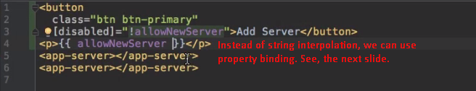
2. 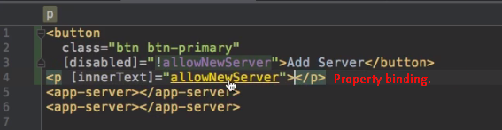
3. Which one to use either **String Interpolation** or **Property Binding?**
   1. **String Interpolation:** When to output some text.
   2. **Property Binding:** When to change the property of an element.
4. **NOTE**: Don’ t mix property binding and string interpolation 